OBEX Messaging Test Stub - Description

Security Classification: | Internal – Symbian
Document Reference: | SXX.XXXnnn.nnn
Status: | DRAFT
Version: | 0.2
Last Revised Date: | 7 January 2004
Team/Department : | Messaging
Author(s): | Oscar González, Graham Leak
Owner(s): | Oscar González

Approver(s): | Emlyn Howell  Helena Bryant | Distribution: | Emlyn Howell  Helena Bryant

Contents
1 Introduction 3
1.1 Purpose and Scope 3
2 Design 3
2.1 Requirements 3
2.2 Component interaction 3
2.3 OBEX Messaging Test Stub classes 4
2.4 Send Operation State Diagram 4
3 Implementation 6
3.1 IROBEX 6
3.2 SDP AGENT 6
3.3 Build Instructions 6
4 Testing 6
4.1 Test Harness 6
4.2 Before running the tests 7
5 Further Information 8
5.1 People 8
5.2 References 8
5.3 Open Issues 8
5.4 Glossary 8
5.5 Document History 8
5.6 Document Review Date 8

Introduction

Purpose and Scope
This document describes the design and implementation of the OBEX Messaging Stub, and gives some instructions for using it to test the OBEX MTMs.

Design

Requirements
The OBEX Messaging Test Stub can be used as a replacement for the low-level OBEX APIs (irobex.dll, irobex.lib), allowing the OBEX MTM message sending code to be tested without requiring a real infrared or Bluetooth connection.
The main requirements were:
- The OBEX Messaging Test Stub had to be both binary and source compatible with the OBEX APIs.
- The test stub had to be configurable and controlled by the test harness.
- The existing test harness had to be updated to support the OBEX stub testing.

Component interaction
The following diagram shows the components that interact with each other during the OBEX MTM code testing.

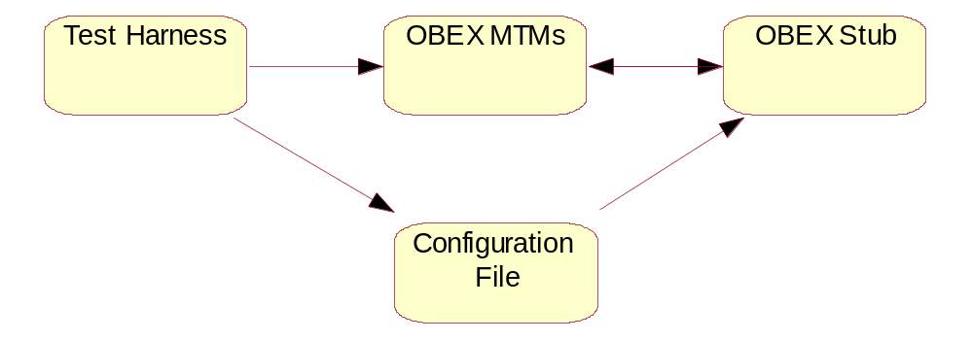
Figure 1

Given that the principal requirement for the OBEX stub was to maintain binary and source compatibility with the real OBEX code, the interaction between Stub and the MTMs is implemented using the same APIs, same callbacks, etc.
Since the test harness can only communicate with the client-side MTMs, and the stub can only talk to the server-side MTMs, there cannot be direct communication between the test harness and the OBEX stub. To work around this problem, an intermediate configuration file is used. The test harness writes the desired behaviour of the operation (success, failure, type of failure) to this file, which is then read by the OBEX stub.

OBEX Messaging Test Stub classes
The main classes in the OBEX Messaging Test Stub are shown in the following diagram:

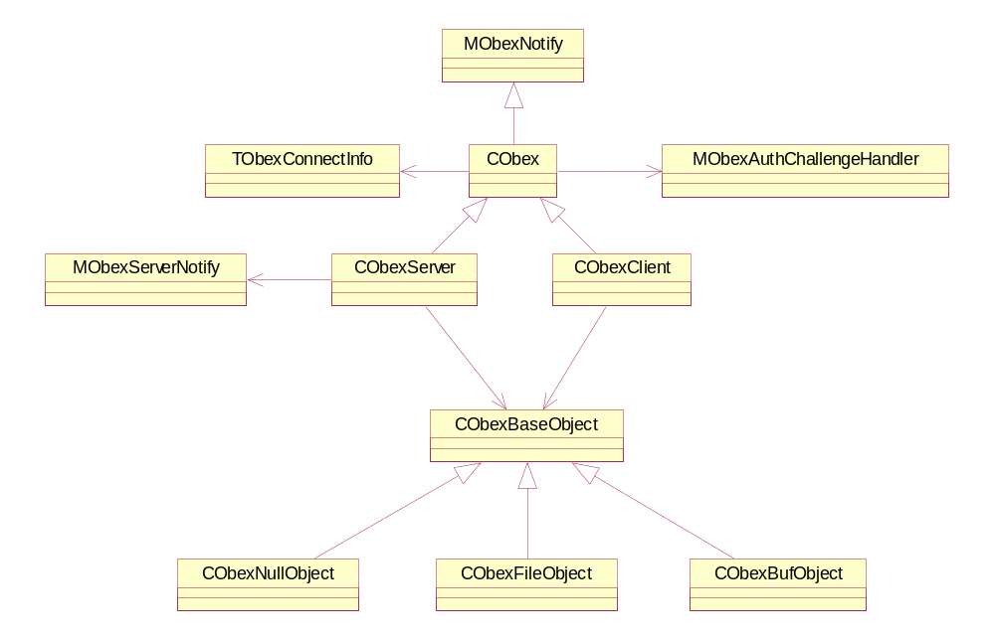
Figure 2

The classes responsible for calling the transport and establishing a real connection in the OBEX APIs have been taken out, as they are not necessary in the test stub and they are not exported in the actual OBEX APIs either.
The main changes for the OBEX stub have been made to class CObexClient, while most of the methods in CObexServer and CObex have been replaced by stub code to keep compatibility with the real OBEX code.

Send Operation State Diagram
In a message send operation, the main functionality is provided by CObexClient, which contains the methods to implement the different stages of the operation. All these methods are asynchronous. They are called from CObexServerSendOperation (in the MTM code) and the result of the requests is handled by CObexServerSendOperation::RealRunL, which implements the state machine of the send operation. This method checks whether each stage of the operation is successful or not, and acts consequently.
The following diagram shows the state diagram of the send operation.
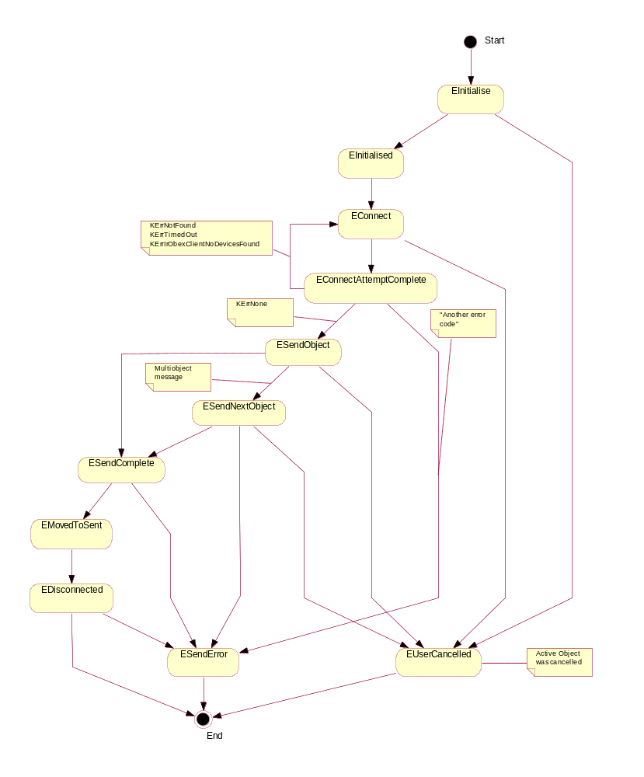
Figure 3

The OBEX Messaging Test Stub, together with the changes made to the test harness code, allow to force the send operation to take any of the possible state flows shown in the diagram above. The desired result of the send operation is specified in the test script, including, if appropriate, at which stage it has to fail.

Implementation

IROBEX
At the start of the send operation, the OBEX client is initialised. At this moment (in the method CObexClient::ConstructL), the desired result is read from the conf.txt file (see Testing section).
The original source code was taken as starting point. The method CObexClient::ClientCommandL, which contained the code to perform the different possible operations (connect, put, disconnect, etc.), was modified so that it completes with a code which depends on the desired result of the send operation, as read from the file.

SDP AGENT
The SDP Agent (sdpagent.dll, sdpagent.lib) had also to be stubbed in order to be able to simulate the Bluetooth SDP queries that take place at the start of the BT send operation.
When an SDP query starts (using the classes CSdpAgent and CSdpAgentEng), a service search request is initiated by calling CSdpSearchRequester::SearchRequestL. In the stub, this request immediately completes and dummy parameters are sent in the call to the method CSdpAgentEng::HandleServiceSearchResponseL.
After that the attribute request is started. The method CSdpAgentEng::AttributeRequestL builds an attribute response that matches what the MTM is expecting for the SDP query to succeed.

Build Instructions
A “readme.txt” file is provided with the OBEX stub, which details the build sequence required to build the above dlls/stubs.

Testing

Test Harness
The current command “send_message” has been updated to support an optional parameter, and to use the “conf.txt” file required by the stub.
The command takes one parameter: the desired result of the send operation. The CObexSendMessage::StartL method then writes this parameter out to the “conf.txt” file. The method also writes any required headers to the file, to allow the stub to verify if the correct headers were received.
The location of the file is currently hard-coded as "C:\msgtest\obexsmoke\stub\conf.txt".
The parameter passed to the “send_message” command can have the following values:
Succeed | everything goes OK
connect_retry | fails to connect and in the second attempts it succeeds
connect_fail | fails to establish a connection
send_next_fail | an error occurs while sending an object
send_complete_fail | an error occurs after it has sent the object(s)
disconnect_fail | an error occurs while disconnecting
init_cancel | operation cancelled during initialisation
connect_cancel | operation cancelled during connection
send_cancel | operation cancelled while sending
send_next_cancel | operation cancelled while sending next object
disconnect_cancel | operation cancelled during disconnection

A sample test script using the new command looks like this:
------------------------------------------
[main]
obex_client_test obex

[obex]
obex_select_mtm bt
set_obex_password test
select_root_folder
create_service
// create the message and set some message attributes
sendas_create
// to get the BT device address from a 7650, type *#2820#
sendas_add_bt_recipient "0002EE30467A"
sendas_set_subject "Who spilt my pint?"
sendas_add_attachment "c:\msgtest\obexsmoke\Photo.jpg"
// save, validate then send the message
sendas_save_message
sendas_validate_message
send_message connect_fail
-------------------------------------------
The only difference to the existing test scripts is the last line, which adds the parameter “connect_fail” to the “send_message” command which we specify that it should fail to establish a connection.
If the stub is not used and the real connection is used instead the “send_message” will ignore the parameter and work in the normal way. This means the same scripts can be used for both the real connection and when the stub.

Before running the tests
In order to run the tests using the OBEX stub, the OBEX library files (irobex.dll, irobex.lib) must be backed up and replaced by the libraries built from the OBEX Test Stub code. To test the Bluetooth MTM it is also necessary to do the same with the SDP Agent libraries (sdpagent.dll, sdpagent.lib).
Remember to copy back the original libraries if you want to run the MTM code again with real connections!

Further Information

People
Role | Person / People
Reviewers | Helena Bryant, Emlyn Howell
Contributors | Graham Leak

References

Open Issues

Glossary
The following technical terms and abbreviations are used within this document.
Term | Definition
MTM | Message Type Module
OBEX | Object Exchange Protocol
SDP | Service Discovery Protocol

Document History
Date | Version | Status | Author | Description
09-10-2003 | 0.1 | Draft | Oscar González | First draft based on SGL.PPS001.501 Formal Document Template Rev 8.0
07-01-2004 | 02 | Draft | Graham Leak | Updates made to test harness description, due to integration of the stub to MCL

Document Review Date

